Analyze the Healthcare cost and Utilization in Wisconsin hospitals
  - SAS and EXCEL DATA SCIENCE COURSE SUBMISSION
Ankit Sharma | SAS and Excel Data Scientist Course | 25 February 2017

To record the patient statistics, the agency wants to find the age category that frequents the hospital and has the maximum expenditure.
- To find the category that has the highest frequency of hospital visits, we can use graphical analysis. A histogram would display the number of occurrences of each age category.

Outlier treatment : NOT REQUIRED
Tasks> Graph>Histogram
Analysis variable : AGE

Result: From the graph that is displayed , we can see that infants have the maximum frequency of hospital visits as rest of the bars don’t match up as high as the bar with age close to 0.

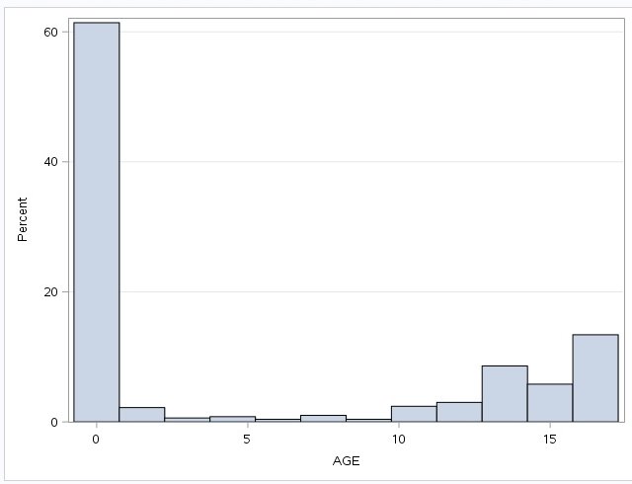

- To find category with maximum expenditure ,we need to perform summary statistics on the total costs categorized by age

Tasks -> Statistics -> Summary Statistics
Analysis Variable: TOTCHG
Classification variable: AGE

Result:
From the result, we can see that the infant category has maximum hospital costs as well (in accordance with the number or frequency of visits). However, if we look at the average costs spent on an age category, ages 9 and 3 have the highest mean.

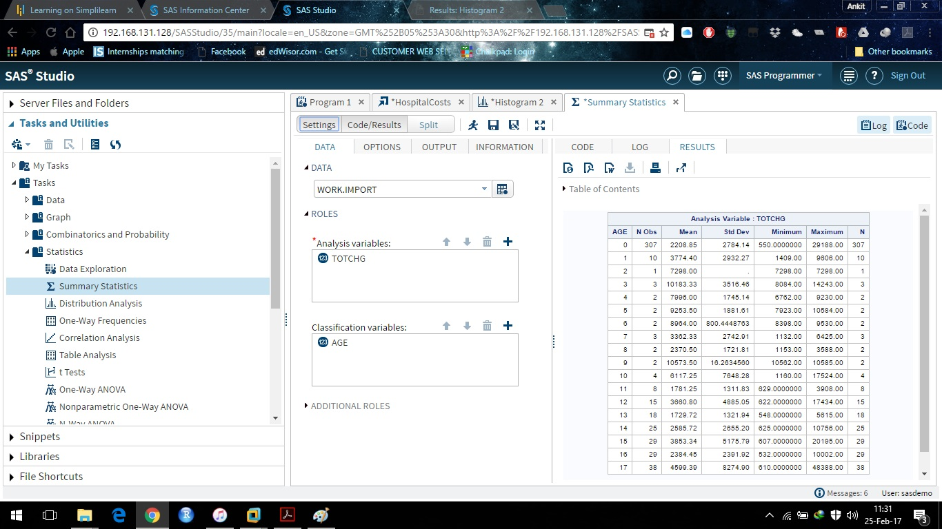

In order of severity of the diagnosis and treatments and to find out the expensive treatments, the agency wants to find the diagnosis related group that has maximum hospitalization and expenditure

Similar to the previous analysis, we can find the diagnosis related group with maximum hospitalization and expenditure, and we will use the summary statistics.

Tasks -> Statistics -> Summary Statistics
Analysis Variables: TOTCHG
Classification Variables: APRDRG

Result:
From the results we can see that the category 640 has the maximum entries of hospitalization, by a huge contrast (267 of 500 entries). Category 911 seems to be the most expensive, with the average going up to 48388 (for a single entry).

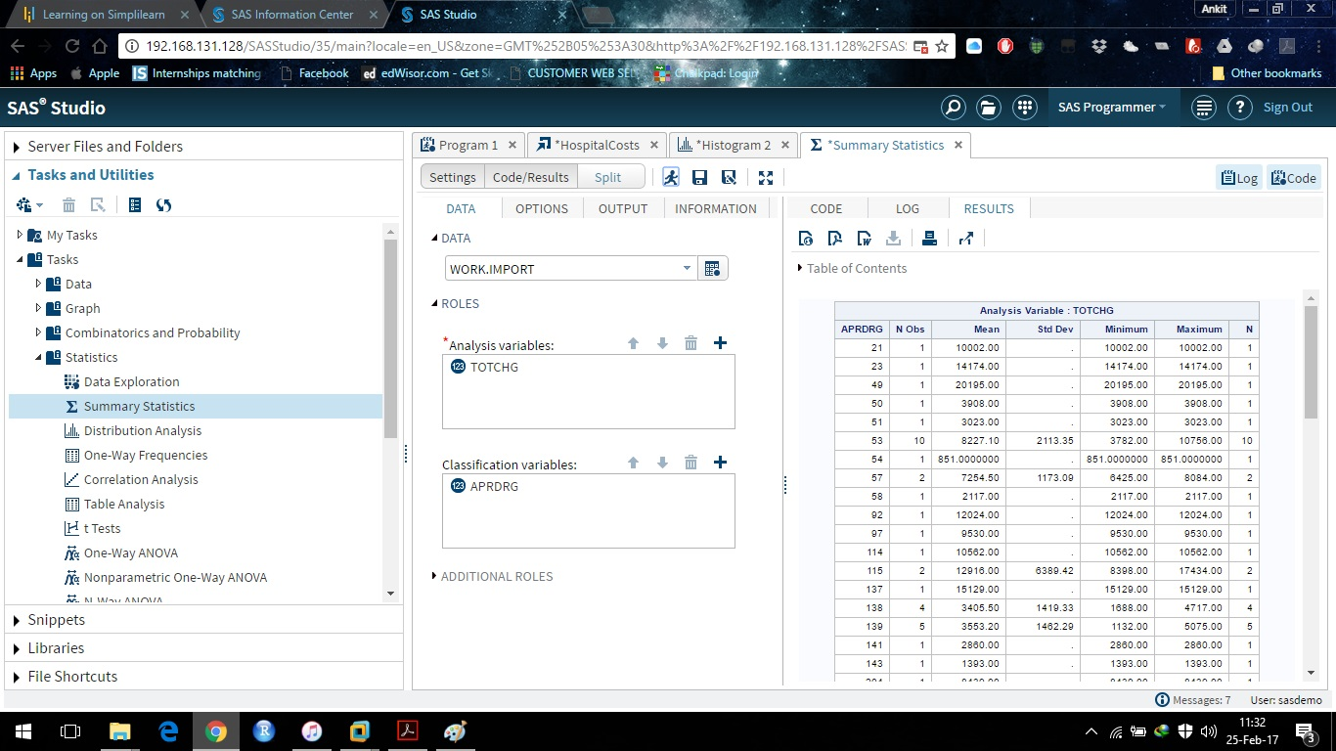

To make sure that there is no malpractice, they need to analyze if the race of the patient is related to the hospitalization costs.

To analyze the above, we perform an analysis of variance on the hospitalization costs, against the race variable.

Tasks -> Statistics -> One-way ANOVA
Dependent variable: TOTCHG
Explanatory variable: RACE

Result:
The p-value is very high, specifying that there is no relation between the race of patient and the hospital costs. Also, from the graph displayed above, we can see that the data has 484 patients of Race1, out of 500 entries. This will affect the results of ANOVA as well, since the number of observations is very much skewed. In conclusion, there is not enough data to verify if the race of patient is related to the hospitalization costs.

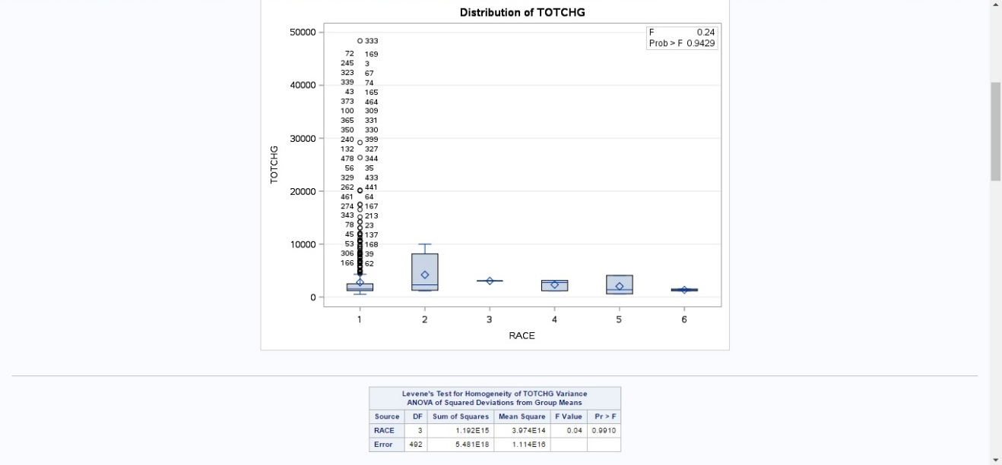

To properly utilize the costs, the agency has to analyze the severity of hospital costs by age and gender for proper allocation of resources.

To analyze the severity of hospital costs, create a linear regression model with the charges as the dependent variable and age as well as gender as the explanatory variables.

Tasks ->Statistcs -> Linear Regression
Dependent variables: TOTCHG
Explanatory variables: FEMALE, AGE

Result:
The p-value is low, suggesting that there is a linear relationship between the variables. The individual p-values suggest that age has more impact than gender on the total costs. The coefficient of FEMALE is negative, suggesting that on an average, females incurred lesser costs than male patients.

Since the length of stay is the crucial factor for inpatients, the agency wants to find if the length of stay can be predicted from age, gender, and race.

Since the length of stay is a continuous variable, we use linear regression to predict the variable. The length of stay is the dependent variable and the age, gender, and race of the patient are the explanatory variables.
Tasks ->Statistcs -> Linear Regression
Dependent variables: TOTCHG
Explanatory variables: FEMALE, AGE, RACE

Result:
From the initial results, we can see that there is no relationship between the explanatory variables and the length of stay, that is, the length of stay cannot be predicted by just using a patient’s age, race, and gender.

To perform a complete analysis, the agency wants to find the variable that mainly affects the hospital costs.

To find the important factors that affect the costs, construct a linear model with all the variables as the causing variables.

Tasks ->Statistcs -> Linear Regression
Dependent variables: TOTCHG
Explanatory variables: FEMALE, AGE, RACE, APRDRG, LOS
Result:
We can see that the age and the length of stay affect the total charges. The length of stay affects the cost positively. That is, with an increase of 1 day, there is an addition of a value of 743 to the total charge.

